**DBMS LAB PROJECT** **MOVENTUR:**

**Conceptual Schema**

**Key Milestone # 0****1**

**Spring 2025**

**CSE-403L**

**Database Management System Lab**

Submitted by:

**Muhammad Musa (22PWCSE2157)**

**Muhammad Jasim (22PWCSE2102)**

Class Section: **‘C’**

“We affirm that we have completed this work with integrity”

Submitted to:

**Engr. Sumayyea Salahuddin**

Sunday, May 25, 2025

Department of Computer Systems Engineering

University of Engineering and Technology, Peshawar

**DBMS Lab Project Moventure: Conceptual Schema**

Entity Description for the Voting and Election Management

|  |  |
| --- | --- |
| **Entity** | **Description** |
| VOTER | A person who has registered and been approved to cast a vote in an election. This individual's identity and eligibility are verified |
| ELECTION | A formal and organized process for electing officials or deciding issues, characterized by specific start and end dates, a name, and a description. |
| CANDIDATE | An individual nominated or sought election to a specific position within an election. Information includes their name, party affiliation, and manifesto. |
| VOTE | The act of a registered voter casting their choice for a specific candidate in a particular election. Each vote is recorded with a timestamp and IP address for verification. |
| Polling STATION | A **Voter** must vote at exactly one **Polling Station** for an **Election**, and a **Polling Station** may serve one or more **Voters**. |

2. Detailed Business Rules for Voting and Election Management System

1. A **Voter** may submit zero or one **Vote** in a given **Election**. Each **Vote** must be submitted by exactly one **Voter**.
2. A **Candidate** must participate in exactly one **Election**, and an **Election** must have one or more **Candidates**.
3. A **Vote** must be cast for exactly one **Candidate**, and a **Candidate** may receive zero or more **Votes**.
4. A **Voter** must vote at exactly one **Polling Station** for an **Election**, and a **Polling Station** may serve one or more **Voters**.
5. An **Election** may have one or more **Polling Stations**, and a **Polling Station** must be associated with exactly one **Election**.

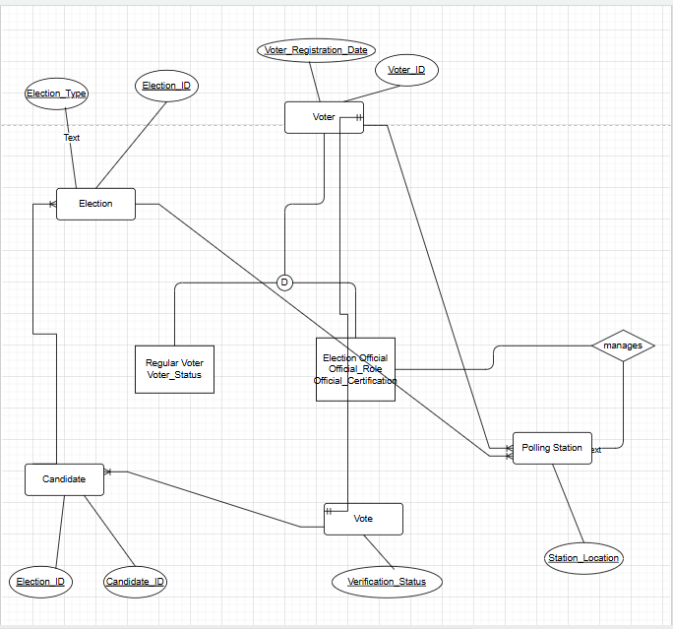

**References**

* <https://grok.com/chat/27983633-f475-4d84-a581-e50639a1456d>
* <https://www.geeksforgeeks.org/how-to-draw-entity-relationship-diagrams>